BÀI TẬP ARDL SỐ 2

NGUYEN QUANG DONG

September 6, 2023

CH0BT2=read.table("D:/dataR/chuong 8/CH0BT2.txt", header=TRUE)  
  
CH0BT2=ts(CH0BT2, start=c(1970), frequency=1)  
Y=CH0BT2[,c(1)]  
plot(Y)

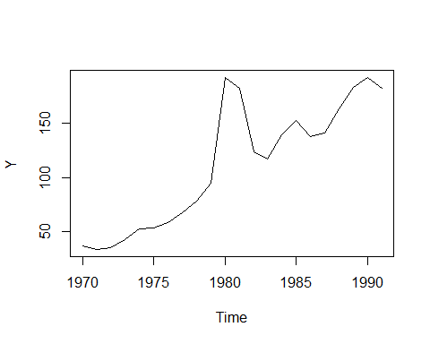

X=CH0BT2[,c(2)]  
plot(X)

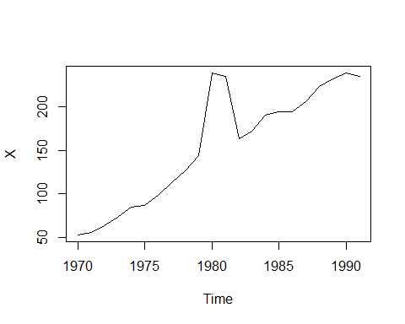

plot(X,Y)

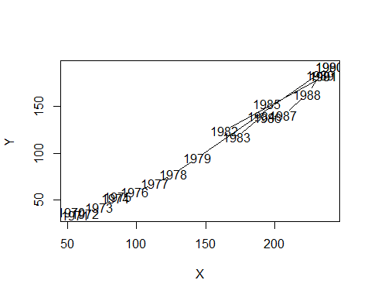 ## UOC LUONG KY VONG MUC DAU TU PHU THUOC THU NHAP: NERLOVE 2

# B?i toan co khoang tin cay/kiem dinh can goi cac packages sau :   
library(sandwich)  
library(car)

## Loading required package: carData

library(carData)  
library(lmtest)

## Loading required package: zoo

##   
## Attaching package: 'zoo'

## The following objects are masked from 'package:base':  
##   
## as.Date, as.Date.numeric

library(sandwich)  
library(zoo)  
# Modul "dynlm" - uoc luong khi co bien tre  
library(dynlm)

# Partial adjustment model - Y = b0+b1*X+ b2*Y(-1)

reg0=dynlm(Y~X+L(Y,1))  
summary(reg0)

##   
## Time series regression with "ts" data:  
## Start = 1971, End = 1991  
##   
## Call:  
## dynlm(formula = Y ~ X + L(Y, 1))  
##   
## Residuals:  
## Min 1Q Median 3Q Max   
## -13.851 -5.995 1.580 4.335 11.492   
##   
## Coefficients:  
## Estimate Std. Error t value Pr(>|t|)   
## (Intercept) -22.93243 4.36718 -5.251 5.41e-05 ***  
## X 0.83775 0.05299 15.809 5.34e-12 ***  
## L(Y, 1) 0.03620 0.06044 0.599 0.557   
## ---  
## Signif. codes: 0 '***' 0.001 '**' 0.01 '*' 0.05 '.' 0.1 ' ' 1  
##   
## Residual standard error: 7.186 on 18 degrees of freedom  
## Multiple R-squared: 0.9856, Adjusted R-squared: 0.984   
## F-statistic: 617.5 on 2 and 18 DF, p-value: < 2.2e-16

resettest(reg0)

##   
## RESET test  
##   
## data: reg0  
## RESET = 5.5483, df1 = 2, df2 = 16, p-value = 0.01478

# Partial adjustment model- Ln(Y) = b0+b1*Ln(X)+ b2*Ln(Y(-1))  
reg=dynlm(log(Y)~log(X)+L(log(Y),1))  
summary(reg)

##   
## Time series regression with "ts" data:  
## Start = 1971, End = 1991  
##   
## Call:  
## dynlm(formula = log(Y) ~ log(X) + L(log(Y), 1))  
##   
## Residuals:  
## Min 1Q Median 3Q Max   
## -0.080153 -0.045621 0.002032 0.034247 0.095286   
##   
## Coefficients:  
## Estimate Std. Error t value Pr(>|t|)   
## (Intercept) -1.40100 0.14135 -9.912 1.02e-08 ***  
## log(X) 1.12735 0.06863 16.426 2.79e-12 ***  
## L(log(Y), 1) 0.08569 0.05374 1.595 0.128   
## ---  
## Signif. codes: 0 '***' 0.001 '**' 0.01 '*' 0.05 '.' 0.1 ' ' 1  
##   
## Residual standard error: 0.05088 on 18 degrees of freedom  
## Multiple R-squared: 0.9934, Adjusted R-squared: 0.9927   
## F-statistic: 1361 on 2 and 18 DF, p-value: < 2.2e-16

resettest(reg)

##   
## RESET test  
##   
## data: reg  
## RESET = 3.1762, df1 = 2, df2 = 16, p-value = 0.06892

# Ham hoi quy DAI HAN???   
   
# CO TON TAI HIEU CHiNH BO PHAN KHONG? HAY GIAI THICH

# ĐỔI DẠNG HÀM-LERLOVE 1-Adaptive Expectations Model  
reg1=dynlm(log(Y)~L(log(X),1)+L(log(Y),1))  
summary (reg1)

##   
## Time series regression with "ts" data:  
## Start = 1971, End = 1991  
##   
## Call:  
## dynlm(formula = log(Y) ~ L(log(X), 1) + L(log(Y), 1))  
##   
## Residuals:  
## Min 1Q Median 3Q Max   
## -0.37480 -0.04296 -0.00891 0.04588 0.57070   
##   
## Coefficients:  
## Estimate Std. Error t value Pr(>|t|)   
## (Intercept) -1.5134 0.7701 -1.965 0.0650 .  
## L(log(X), 1) 1.7372 0.6298 2.758 0.0129 *  
## L(log(Y), 1) -0.5333 0.5286 -1.009 0.3264   
## ---  
## Signif. codes: 0 '***' 0.001 '**' 0.01 '*' 0.05 '.' 0.1 ' ' 1  
##   
## Residual standard error: 0.1706 on 18 degrees of freedom  
## Multiple R-squared: 0.9262, Adjusted R-squared: 0.918   
## F-statistic: 112.9 on 2 and 18 DF, p-value: 6.522e-11

resettest(reg1)

##   
## RESET test  
##   
## data: reg1  
## RESET = 1.3676, df1 = 2, df2 = 16, p-value = 0.2829

# CO TON TAI HIEU CHINH BO PHAN KHONG

## ƯỚC LƯỢNG ĐẦU TƯ KỲ VỌNG PHỤ THUỘC THU NHẬP KỲ VỌNG

reg5=dynlm(Y~X+L(Y,1:2))  
summary (reg5)

##   
## Time series regression with "ts" data:  
## Start = 1972, End = 1991  
##   
## Call:  
## dynlm(formula = Y ~ X + L(Y, 1:2))  
##   
## Residuals:  
## Min 1Q Median 3Q Max   
## -11.395 -5.529 1.156 5.112 10.165   
##   
## Coefficients:  
## Estimate Std. Error t value Pr(>|t|)   
## (Intercept) -24.34955 4.59025 -5.305 7.12e-05 ***  
## X 0.84710 0.05177 16.363 2.06e-11 ***  
## L(Y, 1:2)1 0.11829 0.07993 1.480 0.158   
## L(Y, 1:2)2 -0.09348 0.05882 -1.589 0.132   
## ---  
## Signif. codes: 0 '***' 0.001 '**' 0.01 '*' 0.05 '.' 0.1 ' ' 1  
##   
## Residual standard error: 6.75 on 16 degrees of freedom  
## Multiple R-squared: 0.9874, Adjusted R-squared: 0.985   
## F-statistic: 416.4 on 3 and 16 DF, p-value: 2.17e-15

# CO TON TAI HIEU CHINH BO PHAN KHONG

## KIỂM ĐỊNH QUAN HỆ NHÂN QUẢ VỚI TRỄN k=4

reg6=dynlm(Y~L(Y,1:4)+L(X,1:4))  
summary(reg6)

##   
## Time series regression with "ts" data:  
## Start = 1974, End = 1991  
##   
## Call:  
## dynlm(formula = Y ~ L(Y, 1:4) + L(X, 1:4))  
##   
## Residuals:  
## Min 1Q Median 3Q Max   
## -24.384 -5.886 -0.723 2.573 47.685   
##   
## Coefficients:  
## Estimate Std. Error t value Pr(>|t|)   
## (Intercept) -84.7708 35.8889 -2.362 0.0425 *  
## L(Y, 1:4)1 -0.1423 0.8810 -0.162 0.8752   
## L(Y, 1:4)2 -2.2960 0.9276 -2.475 0.0353 *  
## L(Y, 1:4)3 -1.4174 1.0879 -1.303 0.2250   
## L(Y, 1:4)4 -1.6331 1.0707 -1.525 0.1615   
## L(X, 1:4)1 0.5464 0.8563 0.638 0.5393   
## L(X, 1:4)2 1.6084 0.8827 1.822 0.1018   
## L(X, 1:4)3 1.5932 0.9863 1.615 0.1407   
## L(X, 1:4)4 1.5259 1.0505 1.453 0.1803   
## ---  
## Signif. codes: 0 '***' 0.001 '**' 0.01 '*' 0.05 '.' 0.1 ' ' 1  
##   
## Residual standard error: 21.18 on 9 degrees of freedom  
## Multiple R-squared: 0.9063, Adjusted R-squared: 0.8231   
## F-statistic: 10.88 on 8 and 9 DF, p-value: 0.0008298

# Kiểm định X không ảnh hưởng đến Y   
# tức là kiểm định tất cả các hệ số của X đều bằng 0. Dùng từ khóa "matchCoefs" cho kiểm định hệ số của tất cả các biến có tên"X"  
MyH0_6=matchCoefs(reg6,"X")  
linearHypothesis(reg6,MyH0_6)

## Linear hypothesis test  
##   
## Hypothesis:  
## L(X,4)1 = 0  
## L(X,4)2 = 0  
## L(X,4)3 = 0  
## L(X,4)4 = 0  
##   
## Model 1: restricted model  
## Model 2: Y ~ L(Y, 1:4) + L(X, 1:4)  
##   
## Res.Df RSS Df Sum of Sq F Pr(>F)   
## 1 13 9495.2   
## 2 9 4039.0 4 5456.3 3.0396 0.07656 .  
## ---  
## Signif. codes: 0 '***' 0.001 '**' 0.01 '*' 0.05 '.' 0.1 ' ' 1

## Kiểm định Y không ảnh hưởng đến X

reg7=dynlm(X~L(X,1:4)+L(Y,1:4))  
summary(reg7)

##   
## Time series regression with "ts" data:  
## Start = 1974, End = 1991  
##   
## Call:  
## dynlm(formula = X ~ L(X, 1:4) + L(Y, 1:4))  
##   
## Residuals:  
## Min 1Q Median 3Q Max   
## -23.692 -5.661 -2.443 4.171 43.894   
##   
## Coefficients:  
## Estimate Std. Error t value Pr(>|t|)   
## (Intercept) -68.8486 34.5408 -1.993 0.0774 .  
## L(X, 1:4)1 1.0185 0.8241 1.236 0.2478   
## L(X, 1:4)2 1.5202 0.8495 1.790 0.1071   
## L(X, 1:4)3 1.8438 0.9493 1.942 0.0840 .  
## L(X, 1:4)4 1.7053 1.0110 1.687 0.1259   
## L(Y, 1:4)1 -0.5982 0.8479 -0.705 0.4984   
## L(Y, 1:4)2 -2.3349 0.8927 -2.615 0.0280 *  
## L(Y, 1:4)3 -1.4580 1.0470 -1.392 0.1972   
## L(Y, 1:4)4 -1.9579 1.0305 -1.900 0.0899 .  
## ---  
## Signif. codes: 0 '***' 0.001 '**' 0.01 '*' 0.05 '.' 0.1 ' ' 1  
##   
## Residual standard error: 20.39 on 9 degrees of freedom  
## Multiple R-squared: 0.9283, Adjusted R-squared: 0.8645   
## F-statistic: 14.56 on 8 and 9 DF, p-value: 0.000264

linearHypothesis(reg7,matchCoefs(reg7,"Y"))

## Linear hypothesis test  
##   
## Hypothesis:  
## L(Y,4)1 = 0  
## L(Y,4)2 = 0  
## L(Y,4)3 = 0  
## L(Y,4)4 = 0  
##   
## Model 1: restricted model  
## Model 2: X ~ L(X, 1:4) + L(Y, 1:4)  
##   
## Res.Df RSS Df Sum of Sq F Pr(>F)   
## 1 13 9683.5   
## 2 9 3741.2 4 5942.3 3.5737 0.05209 .  
## ---  
## Signif. codes: 0 '***' 0.001 '**' 0.01 '*' 0.05 '.' 0.1 ' ' 1

# KET LUAN?? TU REG6, REG7

## ĐA THỨC ALMON BẬC 2, TRỄ K=4 THỜI KỲ

Z0 = X+ lag(X,-1)+lag(X,-2)+lag(X,-3)+lag(X,-4)  
Z1=lag(X,-1)+2*lag(X,-2)+3*lag(X,-3)+4*lag(X,-4)  
Z2=lag(X,-1)+4*lag(X,-2)+9*lag(X,-3)+16*lag(X,-4)  
reg8=dynlm(Y~Z0+Z1+Z2)  
summary(reg8)

##   
## Time series regression with "ts" data:  
## Start = 1974, End = 1991  
##   
## Call:  
## dynlm(formula = Y ~ Z0 + Z1 + Z2)  
##   
## Residuals:  
## Min 1Q Median 3Q Max   
## -11.4038 -5.7470 -0.2315 3.7626 16.5968   
##   
## Coefficients:  
## Estimate Std. Error t value Pr(>|t|)   
## (Intercept) -27.77482 6.50841 -4.268 0.000781 ***  
## Z0 0.78566 0.05142 15.278 3.99e-10 ***  
## Z1 -0.69833 0.07245 -9.639 1.47e-07 ***  
## Z2 0.13140 0.01753 7.497 2.89e-06 ***  
## ---  
## Signif. codes: 0 '***' 0.001 '**' 0.01 '*' 0.05 '.' 0.1 ' ' 1  
##   
## Residual standard error: 8.029 on 14 degrees of freedom  
## Multiple R-squared: 0.9791, Adjusted R-squared: 0.9746   
## F-statistic: 218.3 on 3 and 14 DF, p-value: 5.483e-12

# Lay ra uoc luong cac he so cua da thuc ALmon  
czhat=coef(reg8)  
czhat

## (Intercept) Z0 Z1 Z2   
## -27.7748233 0.7856644 -0.6983303 0.1313976

# Tinh cac he so cua mo hinh ban dau  
heso=c(a=czhat[1],b0=czhat[2],b1=czhat[2]+czhat[3]+czhat[4],b2=czhat[2]+2*czhat[3]+4*czhat[4],b3=czhat[2]+3*czhat[3]+9*czhat[4],b4=czhat[2]+4*czhat[3]+16*czhat[4])  
heso

## a.(Intercept) b0.Z0 b1.Z0 b2.Z0 b3.Z0   
## -27.77482327 0.78566443 0.21873173 -0.08540570 -0.12674785   
## b4.Z0   
## 0.09470528

# Tính các se(...) như thế nào? Sinh viên tính tiếp.